**Docker Task**

Install Docker on EC2 and explore the Docker commands (docker images, containers, volumes, network)

**EC2 Instance:**

**Installing Docker on an EC2 instance:**

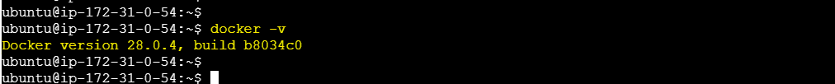

**Docker image commands:**

**Pulling an image:**

**Removing an image:**

**Docker Container:**

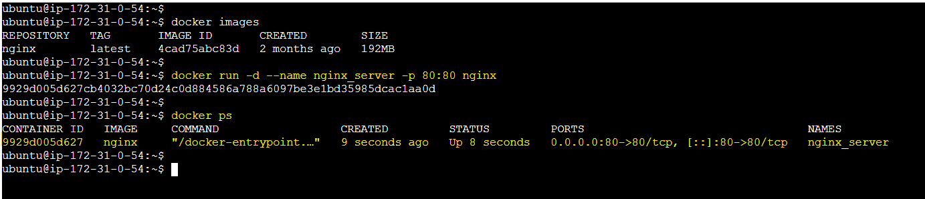

**Output:**

**Stop and remove a container:**

**Docker Volumes:**

**Docker Networks:**

**Docker inspect commands:**

**Output:**

